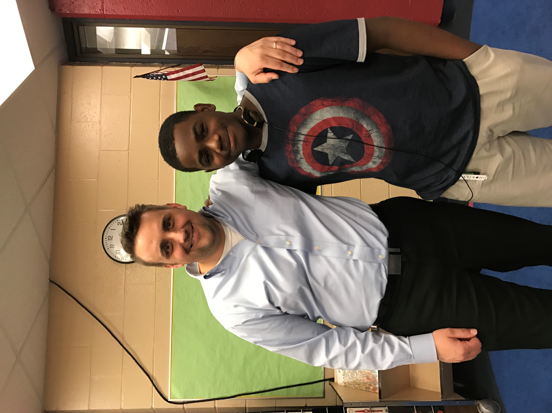

STUDENTS NEED YOU!

*Become a CIS Volunteer*

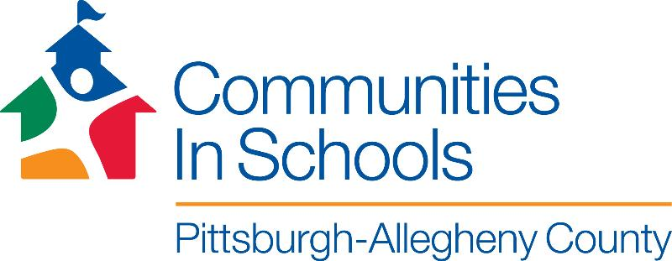

All Students needs a positive one-on-one relationship with a caring adult. At CIS you can be that adult through general volunteer opportunities or by becoming a middle school mentor.

Mentors are needed at the following North Side Pittsburgh schools:

* Morrow Intermediate, Mondays 11:45 am – 12:30 pm
* Allegheny Traditional Academy, Tuesdays 12:50 pm – 1:30 pm and 4:00 pm – 4:50 pm
* Martin Luther King Jr. PreK-8, Wednesdays 11:50 pm – 12:35 pm
* Manchester Academic Charter School, Thursdays 11:30 am – 12:15 pm
* Manchester PreK-8, Fridays 12:30 pm – 1:15 pm.

*Lanajah (8th Grade) and Hayley, 3rd year*

*“I love hanging out with Hayley because she’s my mentor and she’s like my sister. We talk about things going on in my life and school but we also have a lot of fun! ” – Lanajah*

*“I love spending time with Lanajah! She’s the brightest, most enthusiastic, and all-around cool sixth grader in town! I like to talking to her about her school work and playing games, even though I keep getting beat!” Hayley*



For more information about volunteer opportunities

contact Julianna Sehy

[jsehy@cispac.org](mailto:jsehy@cispac.org) | 412-361-4945

www.cispac.org